**Name – Harnoor Singh**

**Enrolment number – E22bcau0017**

**Email Id –** [**e22bcau0017@bennett.edu.in**](mailto:e22bcau0017@bennett.edu.in)

**Subject – Ai and Society**

**Project Name – Lockify**

**About the project –**

**Lockify** a tool that evaluates the strength of a password and provides feedback to help users create stronger, more secure passwords.

**Objective for the project –**

* Evaluate passwords based on:
  + Length (e.g., at least 12 characters).
  + Use of uppercase and lowercase letters.
  + Inclusion of numbers and special characters.
  + Avoidance of common patterns (e.g., "123456", "password").
* Provide feedback on how to improve weak passwords.

**Language used –** Python

**Code for the project –**

import re

def check_password_strength(password):

score = 0

feedback = []

# Check length

if len(password) >= 12:

score += 1

else:

feedback.append("Increase length to at least 12 characters.")

# Check for uppercase and lowercase letters

if any(char.islower() for char in password) and any(char.isupper() for char in password):

score += 1

else:

feedback.append("Use a mix of uppercase and lowercase letters.")

# Check for numbers

if any(char.isdigit() for char in password):

score += 1

else:

feedback.append("Include numbers.")

# Check for special characters

if re.search(r"[!@#$%^&*(),.?\":{}|<>]", password):

score += 1

else:

feedback.append("Add special characters like @, #, $.")

# Check for common patterns

common_patterns = ["123456", "password", "qwerty"]

if any(pattern in password.lower() for pattern in common_patterns):

feedback.append("Avoid common patterns or dictionary words.")

# Determine strength level

if score == 4:

strength = "Strong"

elif score == 3:

strength = "Medium"

else:

strength = "Weak"

return strength, feedback

# Main program

password = input("Enter a password to test: ")

strength, feedback = check_password_strength(password)

print(f"Password Strength: {strength}")

if feedback:

print("Suggestions to improve your password:")

for tip in feedback:

print(f"- {tip}")

link for the project - <https://www.programiz.com/online-compiler/5BTOYSgZ0FbW2>

( this project is done on online compiler but the code has been shared and the project is in working conditions , this was created on online compiler since my laptop had some virus and hardware issues so this project is completed in a cybercafe)

Images for the various outcomes –

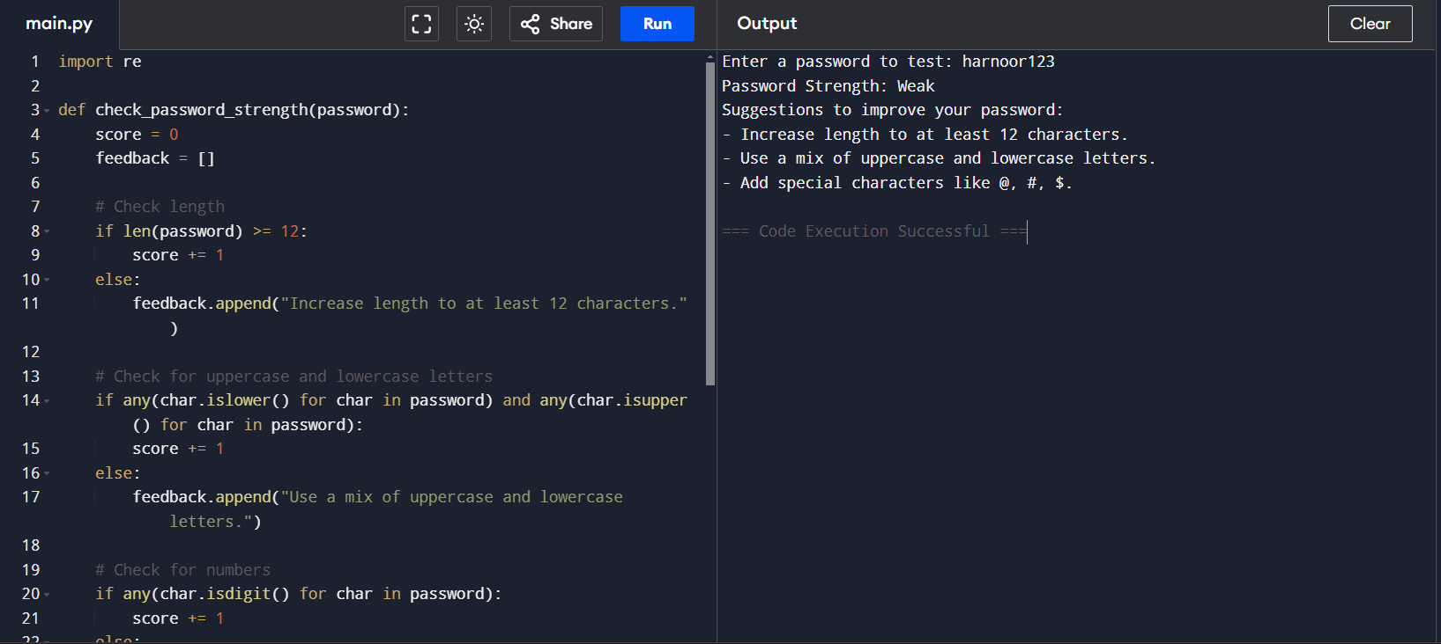

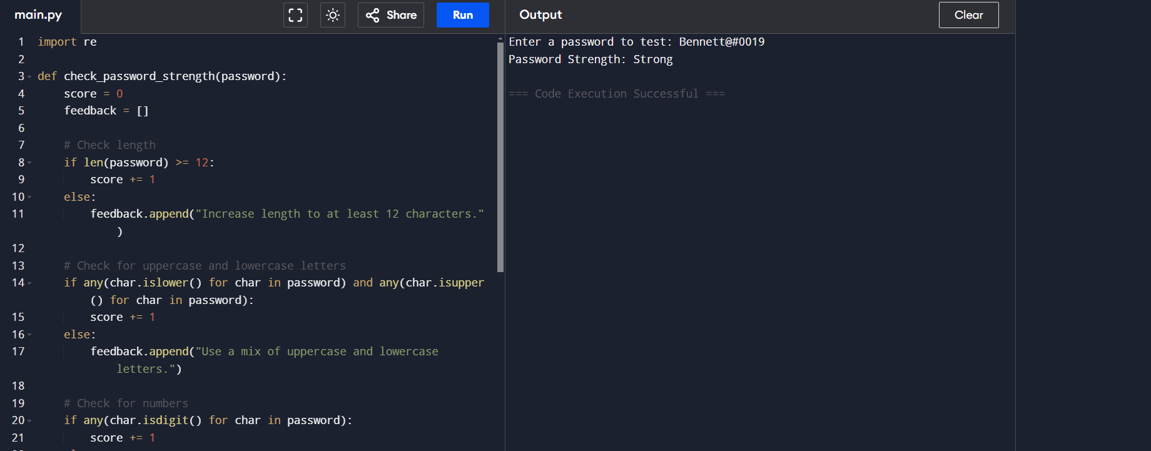

Thank you